PAINT BRANCH CREEK
HOUSE CONCERT INFO
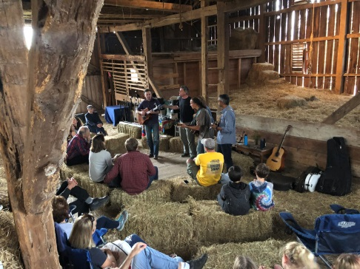
What is a House Concert? A house concert is a chance to experience music in a friendly, intimate environment. Someone opens their home and invites friends, neighbors, co-workers, etc. into their living room to share in a performance. You can really connect with the musicians, see a performance up close, and maybe even request a song. As the host you get to create the atmosphere you want and can invite as many guests as your living room, basement or garden can hold!
Unlike a house party that has some music going on in the background, at a house concert the audience’s attention is focused on the performers, with time for socializing before and after the concert, at the host’s discretion.
Though not necessary, many hosts often chose to include some kind of pot-luck style food along with the house concert. Anything goes, from a full-on meal to light snacks, wine and cheese, or dessert. Having some kind of snacking option is a nice way to facilitate interaction between guests who may not know each other.
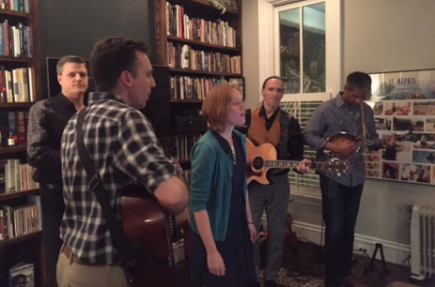
House concerts are a vital part of the folk music scene throughout the United States. They’re also a great way to build community while connecting to live music. Plus you can talk to the band and hear the stories behind some of your favorite songs!

What do I have do? You invite your friends over to watch a live show. Your friends get a personalized, up close environment in which to hear great music. Try to secure at least 20 people. PBC will provide you with a short bio and some highlights to entice potential audience members.
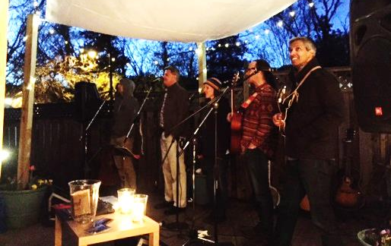
If you don’t think you can get 20 people together, there are options. Perhaps one of your friends would be willing to co-host and help with invitations? Or perhaps they have friends who will bring in additional people. Remember neighbors, co-workers, relatives and church/temple members, etc. might like to attend. In order to make a house concert worthwhile, you typically need to have a minimum of 20 people at the show. Twenty-five, thirty, or more is even better if you have the space.

How are artists compensated? A donation of $10 – $20 per person is customary at house concerts, or we can also negotiate a flat fee if you want to treat your guests to a concert. If you opt to collect money from guests, we can offer tips on how to make that work.

Then what? Relax in your most comfortable chair and enjoy live music in your home! It does require a little bit of work, but imagine enjoying live, acoustic music in your own home! You’ll get a chance to spend some time with the artist and get to know them.

Email PBC to have a house concert at your place!
PaintBranchCreek@gmail.com

PaintBranchCreek.com

